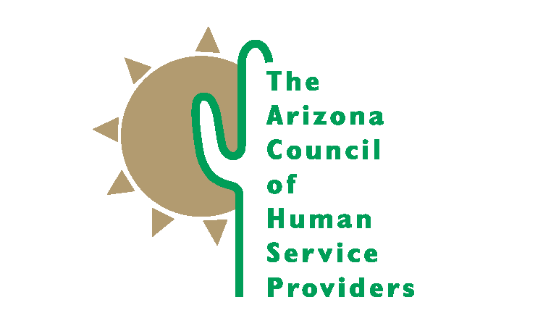
2100 N. Central Avenue, Suite 225 Phoenix, Arizona 85004
602-252-9363 Fax 602-252-8664

ACCOMPLISHMENTS 2018-19

Advocacy Efforts
Arizona Council staff monitored almost 600 bills during the 2019 legislative session related to behavoral health, child welfare, juvenile justice, and other related topics. We were able to ensure passage of key pieces of behaivoral health and child welfare legislation, while keeping some misguided policy solutions from moving forward. Arizona Council staff, lobbyists, and members actively engaged in study committees and stakeholder meetings adding the voice of the providers and a reality check for legislators. Our engagement was sought after and appreciated by legislators and staff who asked for our assistance in finding members for stakeholders groups.

We provided weekly legislative updates to our members. We supported our members in building relationships with their state and federal elected officals through our annual Day at the Capitol and Hill Day events. Our legislative, congressional, and administrative advocacy efforts established the Arizona Council as a credible resource to elected offcials, legislative staff, the governors office, and state agencies. We are seen as a problem solving resource for policy makers.

Member Services
The Arizona Council is only as strong as our member organizations. Our 112 members employ over 30,000 staff, operate over 700 facilities, and serve almost a million children, adults, and families. Together, we are a force to be reckoned with. Member organizations receive many benefits of membership including regular communication and technical assistance from Arizona Council staff.

Through monthly general membership and committee meetings with our members, we are able to communicate, learn from, and support each other. Quarterly forums with state agency representatives are held in September, December, March, and June. Community forum topics included presentations on Census 2020, DD behavioral health integration, tools for patient engagement, collaborative care models for behavioral health, updates from Health Current on the Health Information Exchange implementation and the Board of Behavioral Health Examiners. Monthly updates are provided to member agencies via email. We also hold monthly meetings with staff from AHCCCS and had regular participation of DCS staff in the Child Welfare committee.

In anticipation of the 10/1/2018 Arizona Complete Care transition, the Arizona Council intiated educational forums for Health Plan staff prior to implementation of integrated care. Prior to and since the transition, Council staff have worked closely with AHCCCS staff to identify and mediate problems that resulted from the transition. We held daily and then weekly conference calls with our members to identify issues and concerns and worked with the Health Plans to address those concerns. At AHCCCSs request we hosted several multiday sessions individually with the Health Plans to address contracting, claims, and credentialing concerns unique to each plan.

We held our 2018 Member Conference, Thriving in Times of Change, November 29-30 at the Black Canyon Conference Center. Over 200 people attended the two day event and enjoyed 5 keynotes, three thought leader panels, and 24 workshops.

We completed our 8th biannual Salary/Benefit Survey, which surveyed over 50 positions and added 27 benefits questions as well. The Survey was available to purchase in the fall 2018.

Specific Iniatives

- 1115 Waiver, Targeted Investment Project
- AHCCCS Complete Care Implementation
- AHCCCS Policy Committee
- AOC Task Force on Juvenile Detention Alternatives Initiatives
- Arizona Coalition for Insurance Parity
- Arizona State Health Improvement Plan
- Behavioral Health System Reform
- Building Relationships with Health Plans Educational Forums
- Center for Child Well Being Advisory Board
- Collective Impact Project on Child Welfare
- Day at the Capitol and Hill Day Advocacy Efforts
- DCS Community Advisory Board
- DCS Report Consolidation Work Group
- Family First Prevention Services Act Implementation
- Housing and treatment continuum for those with SMI diagnoses
- Initiation of AZ Neurosequential Model Consortium
- Mental Health America Arizona Board
- Restoration of the Housing Trust Fund
- Salary/Benefit Survey (biannual)
- Workforce Development Data Collection Workgroup

Arizona Foundation for Human Service Providers

Behavioral Health Interpreter Academy
The Arizona Foundation for Human Service Providers launched the innovative Behavioral Health Interpreter Academy in August 2015. The Interpreter Academy is a 6 week blended learning training program for bilingual individuals who provide interpretation services in their agencies. Ten classes were held since 2015. Participants consistently report they have learned both the interpretation skills and Spanish language vocabulary needed to provide higher quality services to monolingual Spanish speaking clients.

Neurosequential Model in Caregiving
We continued implementmentation of the Neurosequential Model in Caregiving, a foster parent trauma informed care training program. This is a three year collaboration with the ChildTrauma Academy and Dr Bruce Perry. We are building a library of video and other resources and training 40 facilitators to continue the program. Over 2,000 unique individuals people watched the first 17 webinars—either live or through the archived video library. This includes foster, kinship, and adoptive families, child welfare and behavioral health staff, and DCS staff. The Train the Trainer Facilitator Training progam began in the fall 2017 with 42 participants and the Master Trainer group began in February 2019. Three program evaluations were completed, demonstrating that most people who watched the webinars are benefiting from them.

ECSII (Early Childhood Service Intensity Instrument) Facilitator Training
AHCCCS asked the Arizona Foundation for Human Service Providers to coordinate a “train the trainer” training program for providers receiving Targeted Investment funding to begin using the ECSII for screening children ages birth to five. We trained 36 facilitators and an additional 33 staff to use the ECSII in June 2018. They will then continue to provide training to other service providers in their agency and begin using a uniform screening tool for very young children and their families. We report the number of providers trained to the American Academy of Child and Adolescent Psychiatry.

UoA Supervisors Training Program
We were asked by the University of Arizona to apply with them for a Regional Public Health Training Center Program Grant. The grant was awarded beginning July 2018 to ascertain the training needs of our public health workforce. We completed a needs assessment survey of direct service staff, supervisors, and managers in March/Arpil 2019. We will be developing a training outline, marketing training programs to our members, and developing a blending learning training program for new supervisors and middle managers over the next year.

